**LAB TASK#1**

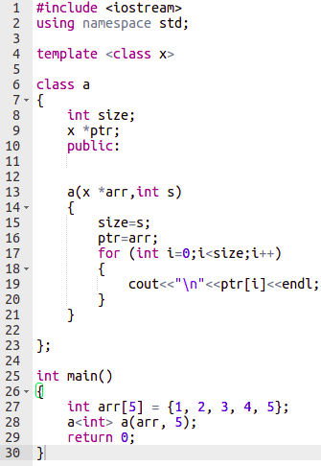

**OUTPUT**

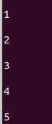

**LAB TASK#4**

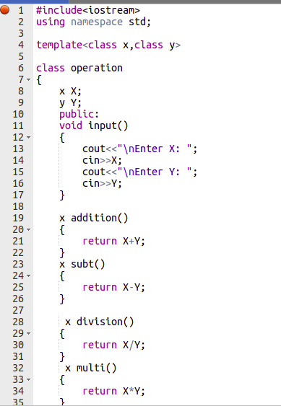

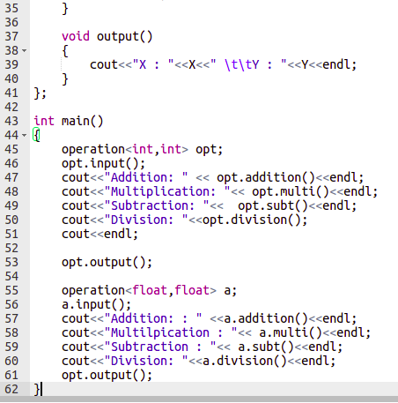

**OUTPUT**

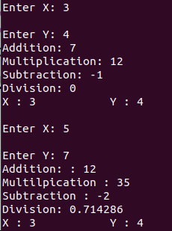

**Conclusion:**

In this lab learned how to apply templates in classes of C++. With the help of templates we can add any data type to our classes and templates also help us to reduce our code.